**Estructura del Proyecto**

1. **Ms-participantes**

**Estructura de Paquetes:**

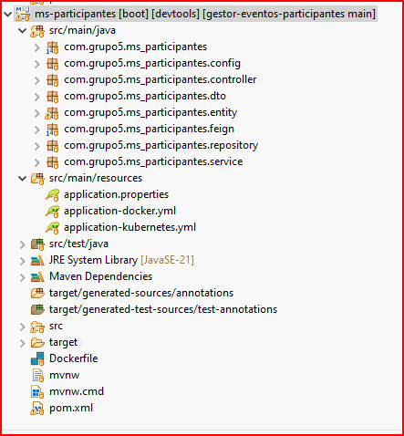

**Application.properties**

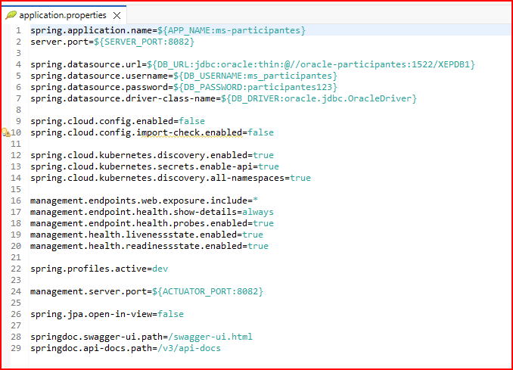

**Application-docker.yml**

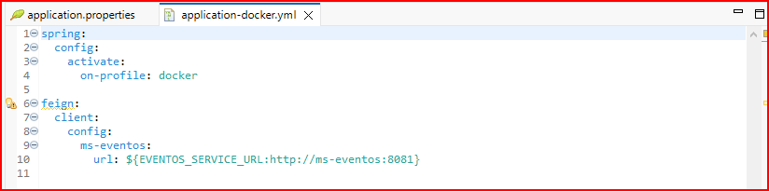

**Application-kubernetes.yml**

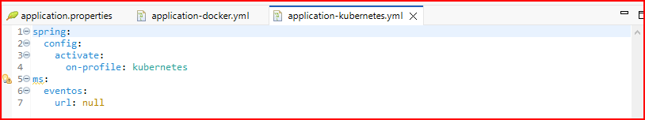

**Pom.xml**

|  |
| --- |
| <?xml version="1.0" encoding="UTF-8"?>  <project xmlns="http://maven.apache.org/POM/4.0.0" xmlns:xsi="http://www.w3.org/2001/XMLSchema-instance"  xsi:schemaLocation="http://maven.apache.org/POM/4.0.0 https://maven.apache.org/xsd/maven-4.0.0.xsd">  <modelVersion>4.0.0</modelVersion>  <parent>  <groupId>org.springframework.boot</groupId>  <artifactId>spring-boot-starter-parent</artifactId>  <version>3.4.4</version>  <relativePath/> <!-- lookup parent from repository -->  </parent>  <groupId>com.grupo5</groupId>  <artifactId>ms-participantes</artifactId>  <version>0.0.1-SNAPSHOT</version>  <name>ms-participantes</name>  <description>Microservicio para gestión de participantes</description>  <url/>  <licenses>  <license/>  </licenses>  <developers>  <developer/>  </developers>  <scm>  <connection/>  <developerConnection/>  <tag/>  <url/>  </scm>  <properties>  <java.version>21</java.version>  <spring-cloud.version>2024.0.1</spring-cloud.version>  </properties>  <dependencies>  <dependency>  <groupId>org.springframework.boot</groupId>  <artifactId>spring-boot-starter-actuator</artifactId>  </dependency>  <dependency>  <groupId>org.springframework.boot</groupId>  <artifactId>spring-boot-starter-data-jpa</artifactId>  </dependency>  <dependency>  <groupId>org.springframework.boot</groupId>  <artifactId>spring-boot-starter-web</artifactId>  </dependency>  <dependency>  <groupId>org.springframework.cloud</groupId>  <artifactId>spring-cloud-starter-config</artifactId>  </dependency>  <dependency>  <groupId>org.springframework.cloud</groupId>  <artifactId>spring-cloud-starter-gateway-mvc</artifactId>  </dependency>  <dependency>  <groupId>org.springframework.cloud</groupId>  <artifactId>spring-cloud-starter-kubernetes-client-all</artifactId>  </dependency>  <dependency>  <groupId>org.springframework.cloud</groupId>  <artifactId>spring-cloud-starter-openfeign</artifactId>  </dependency>  <dependency>  <groupId>org.springdoc</groupId>  <artifactId>springdoc-openapi-starter-webmvc-ui</artifactId>  <version>2.8.6</version>  </dependency>  <dependency>  <groupId>org.springframework.boot</groupId>  <artifactId>spring-boot-devtools</artifactId>  <scope>runtime</scope>  <optional>true</optional>  </dependency>  <dependency>  <groupId>com.oracle.database.jdbc</groupId>  <artifactId>ojdbc11</artifactId>  <scope>runtime</scope>  </dependency>  <dependency>  <groupId>org.projectlombok</groupId>  <artifactId>lombok</artifactId>  <version>1.18.38</version>  <scope>provided</scope>  </dependency>  <dependency>  <groupId>org.springframework.boot</groupId>  <artifactId>spring-boot-starter-test</artifactId>  <scope>test</scope>  </dependency>  <dependency>  <groupId>org.springframework.boot</groupId>  <artifactId>spring-boot-configuration-processor</artifactId>  <optional>true</optional>  </dependency>  </dependencies>  <dependencyManagement>  <dependencies>  <dependency>  <groupId>org.springframework.cloud</groupId>  <artifactId>spring-cloud-dependencies</artifactId>  <version>${spring-cloud.version}</version>  <type>pom</type>  <scope>import</scope>  </dependency>  </dependencies>  </dependencyManagement>  <build>  <plugins>  <plugin>  <groupId>org.apache.maven.plugins</groupId>  <artifactId>maven-surefire-plugin</artifactId>  <version>3.0.0-M5</version>  <configuration>  <skipTests>true</skipTests>  </configuration>  </plugin>  <plugin>  <groupId>org.apache.maven.plugins</groupId>  <artifactId>maven-compiler-plugin</artifactId>  <configuration>  <annotationProcessorPaths>  <path>  <groupId>org.projectlombok</groupId>  <artifactId>lombok</artifactId>  </path>  </annotationProcessorPaths>  </configuration>  </plugin>  <plugin>  <groupId>org.springframework.boot</groupId>  <artifactId>spring-boot-maven-plugin</artifactId>  <configuration>  <excludes>  <exclude>  <groupId>org.projectlombok</groupId>  <artifactId>lombok</artifactId>  </exclude>  </excludes>  </configuration>  </plugin>  </plugins>  </build>  </project> |

1. **Ms-eventos**

**Estructura de Paquetes**

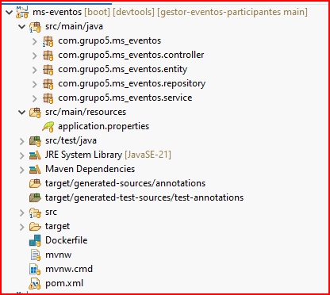

**Application.properties**

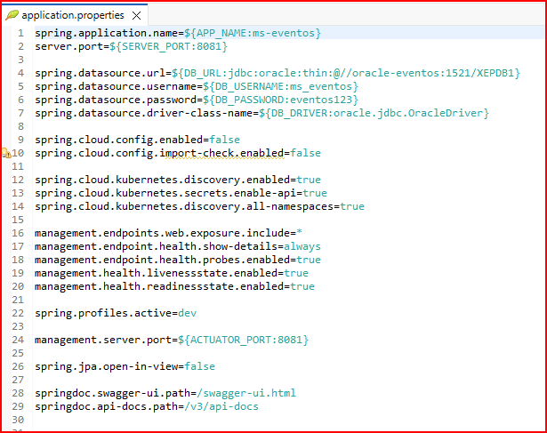

**Pom.xml**

|  |
| --- |
| <?xml version="1.0" encoding="UTF-8"?>  <project xmlns="http://maven.apache.org/POM/4.0.0" xmlns:xsi="http://www.w3.org/2001/XMLSchema-instance"  xsi:schemaLocation="http://maven.apache.org/POM/4.0.0 https://maven.apache.org/xsd/maven-4.0.0.xsd">  <modelVersion>4.0.0</modelVersion>  <parent>  <groupId>org.springframework.boot</groupId>  <artifactId>spring-boot-starter-parent</artifactId>  <version>3.4.4</version>  <relativePath/> <!-- lookup parent from repository -->  </parent>  <groupId>com.grupo5</groupId>  <artifactId>ms-eventos</artifactId>  <version>0.0.1-SNAPSHOT</version>  <name>ms-eventos</name>  <description>Microservicio para gestión de eventos</description>  <url/>  <licenses>  <license/>  </licenses>  <developers>  <developer/>  </developers>  <scm>  <connection/>  <developerConnection/>  <tag/>  <url/>  </scm>  <properties>  <java.version>21</java.version>  <spring-cloud.version>2024.0.1</spring-cloud.version>  </properties>  <dependencies>  <dependency>  <groupId>org.springframework.boot</groupId>  <artifactId>spring-boot-starter-actuator</artifactId>  </dependency>  <dependency>  <groupId>org.springframework.boot</groupId>  <artifactId>spring-boot-starter-data-jpa</artifactId>  </dependency>  <dependency>  <groupId>org.springframework.boot</groupId>  <artifactId>spring-boot-starter-web</artifactId>  </dependency>  <dependency>  <groupId>org.springframework.cloud</groupId>  <artifactId>spring-cloud-starter-config</artifactId>  </dependency>  <dependency>  <groupId>org.springframework.cloud</groupId>  <artifactId>spring-cloud-starter-gateway-mvc</artifactId>  </dependency>  <dependency>  <groupId>org.springframework.cloud</groupId>  <artifactId>spring-cloud-starter-openfeign</artifactId>  </dependency>  <dependency>  <groupId>org.springdoc</groupId>  <artifactId>springdoc-openapi-starter-webmvc-ui</artifactId>  <version>2.8.6</version>  </dependency>  <dependency>  <groupId>org.springframework.boot</groupId>  <artifactId>spring-boot-devtools</artifactId>  <scope>runtime</scope>  <optional>true</optional>  </dependency>  <dependency>  <groupId>com.oracle.database.jdbc</groupId>  <artifactId>ojdbc11</artifactId>  <scope>runtime</scope>  </dependency>  <dependency>  <groupId>org.projectlombok</groupId>  <artifactId>lombok</artifactId>  <version>1.18.38</version>  <scope>provided</scope>  </dependency>  <dependency>  <groupId>org.springframework.boot</groupId>  <artifactId>spring-boot-starter-test</artifactId>  <scope>test</scope>  </dependency>  <dependency>  <groupId>org.springframework.cloud</groupId>  <artifactId>spring-cloud-starter-kubernetes-client-all</artifactId>  </dependency>  </dependencies>  <dependencyManagement>  <dependencies>  <dependency>  <groupId>org.springframework.cloud</groupId>  <artifactId>spring-cloud-dependencies</artifactId>  <version>${spring-cloud.version}</version>  <type>pom</type>  <scope>import</scope>  </dependency>  </dependencies>  </dependencyManagement>  <build>  <plugins>  <plugin>  <groupId>org.apache.maven.plugins</groupId>  <artifactId>maven-surefire-plugin</artifactId>  <version>3.0.0-M5</version>  <configuration>  <skipTests>true</skipTests>  </configuration>  </plugin>  <plugin>  <groupId>org.apache.maven.plugins</groupId>  <artifactId>maven-compiler-plugin</artifactId>  <configuration>  <annotationProcessorPaths>  <path>  <groupId>org.projectlombok</groupId>  <artifactId>lombok</artifactId>  </path>  </annotationProcessorPaths>  </configuration>  </plugin>  <plugin>  <groupId>org.springframework.boot</groupId>  <artifactId>spring-boot-maven-plugin</artifactId>  <configuration>  <excludes>  <exclude>  <groupId>org.projectlombok</groupId>  <artifactId>lombok</artifactId>  </exclude>  </excludes>  </configuration>  </plugin>  </plugins>  </build>  </project> |

1. **Ms-gateway**

**Estructura de Paquetes**

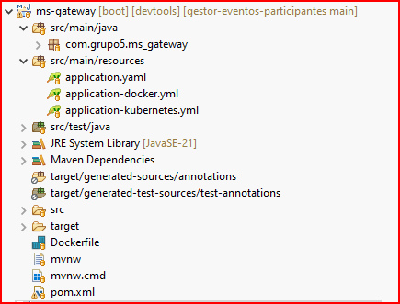

**Application.yaml**

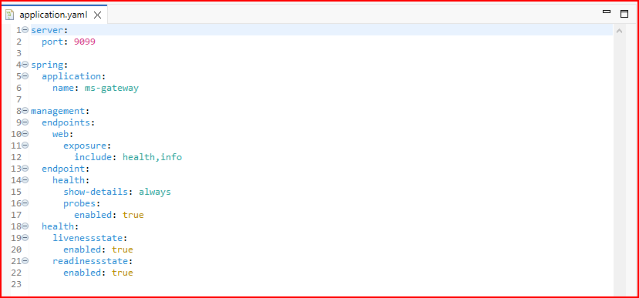

**Application_docker.yaml**

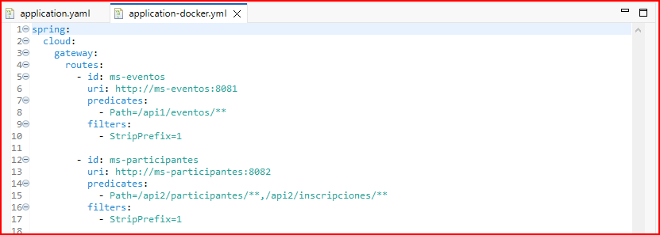

**Application_kubernetes.yml**

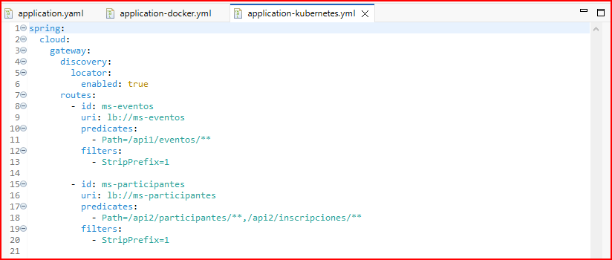

**Pom.xml**

|  |
| --- |
| <?xml version="1.0" encoding="UTF-8"?>  <project xmlns="http://maven.apache.org/POM/4.0.0" xmlns:xsi="http://www.w3.org/2001/XMLSchema-instance"  xsi:schemaLocation="http://maven.apache.org/POM/4.0.0 https://maven.apache.org/xsd/maven-4.0.0.xsd">  <modelVersion>4.0.0</modelVersion>  <parent>  <groupId>org.springframework.boot</groupId>  <artifactId>spring-boot-starter-parent</artifactId>  <version>3.4.5</version>  <relativePath/> <!-- lookup parent from repository -->  </parent>  <groupId>com.grupo5</groupId>  <artifactId>ms-gateway</artifactId>  <version>0.0.1-SNAPSHOT</version>  <name>ms-gateway</name>  <description>Gestionar las rutas hacia los microservicios</description>  <url/>  <licenses>  <license/>  </licenses>  <developers>  <developer/>  </developers>  <scm>  <connection/>  <developerConnection/>  <tag/>  <url/>  </scm>  <properties>  <java.version>21</java.version>  <spring-cloud.version>2024.0.1</spring-cloud.version>  </properties>  <dependencies>  <dependency>  <groupId>org.springframework.cloud</groupId>  <artifactId>spring-cloud-starter-gateway</artifactId>  </dependency>  <dependency>  <groupId>org.springframework.cloud</groupId>  <artifactId>spring-cloud-starter-kubernetes-client</artifactId>  </dependency>  <dependency>  <groupId>org.springframework.cloud</groupId>  <artifactId>spring-cloud-starter-kubernetes-client-config</artifactId>  </dependency>  <dependency>  <groupId>org.springframework.cloud</groupId>  <artifactId>spring-cloud-starter-kubernetes-client-loadbalancer</artifactId>  </dependency>  <dependency>  <groupId>org.springframework.boot</groupId>  <artifactId>spring-boot-starter-actuator</artifactId>  </dependency>  <dependency>  <groupId>org.springframework.boot</groupId>  <artifactId>spring-boot-devtools</artifactId>  <scope>runtime</scope>  <optional>true</optional>  </dependency>  <dependency>  <groupId>org.springframework.boot</groupId>  <artifactId>spring-boot-starter-test</artifactId>  <scope>test</scope>  </dependency>  </dependencies>  <dependencyManagement>  <dependencies>  <dependency>  <groupId>org.springframework.cloud</groupId>  <artifactId>spring-cloud-dependencies</artifactId>  <version>${spring-cloud.version}</version>  <type>pom</type>  <scope>import</scope>  </dependency>  </dependencies>  </dependencyManagement>  <build>  <plugins>  <plugin>  <groupId>org.apache.maven.plugins</groupId>  <artifactId>maven-surefire-plugin</artifactId>  <version>3.0.0-M5</version>  <configuration>  <skipTests>true</skipTests>  </configuration>  </plugin>  <plugin>  <groupId>org.springframework.boot</groupId>  <artifactId>spring-boot-maven-plugin</artifactId>  </plugin>  </plugins>  </build>  </project> |